Data Integration Framework
Developer’s Guide

MassHealth Data Warehouse

(Document History is at the end)
Contents
1 This Document 4
2 Motivation 4
3 Data Integration Metadata 4
4 SQL in the Data Integration framework 6
4.1 Executing SQL from DI 6
4.2 Support for Business Analysts 6
4.3 The DI SQL Parser 7
5 Executables 9
6 Process Logs 10
7 Self-Service Web Application 10
8 Development Environments 11
8.1 Eclipse 11
8.2 Subversion 12
8.3 Web tools 13
8.4 Visual Studio 13
9 Implementation 14
9.1 Data Access 14
9.2 Command Execution 15
9.3 Java Processes 16
9.4 SQL Generation 16
9.5 Excel Import and Export 16
9.6 Data Integration Commands Editor 17
10 Authentication 18
11 Commands 18
11.1 AddDataToTable 19
11.2 AddToTableWithGeneratedScripts 19
11.3 Comment 19
11.4 ConvertTextToAvro 20
11.5 CopyLargeTable 20
11.6 CopyRecords 20
11.7 CopyTable 20
11.8 DownloadFileFromWeb 21
11.9 ExecuteConfiguredScript 21
11.10 ExecuteGeneratedScripts 21
11.11 ExecuteJavaProcess 21
11.12 ExecuteScript 22
11.13 ExportDataToExcel 22
11.14 ExportTableToFile 23
11.15 ExportTableToText 23
11.16 ExtractDataToTable 23
11.17 FillTableWithGeneratedScripts 24
11.18 ForEachRecordOfTable 24
11.19 ImportExcelToTable 24
11.20 ImportFileToTable 25
11.21 ImportTextToTable 25
11.22 ListFilesInFolder 25
11.23 NextRecordOfTable 26
11.24 PrepareToRecordJobHistory 26
11.25 RunShellCommand 26
11.26 RunSubProcess 26
11.27 S3CopyFile 26
11.28 SendEmail 27
11.29 SendEmailOnFailure 27
11.30 SetEmailAttachment 27
11.31 SetExcelExportData 28
11.32 SetScriptParameter 28
11.33 SetVariable / SetProcessParameter 28
11.34 SetVariableWithProperty 29
11.35 SetVariables 29
11.36 SFTPCopyFile 29
11.37 SubProcess 30
11.38 Validate 30
12 Future Work 31
13 Document History 31

This Document
This document is a Developer’s Guide for the Data Integration Framework (DIF), a homegrown development tool for building Extract, Transform and Load (ETL) processes. It includes information for ETL developers working with SQL, and also Java developers using and extending the framework.
At this time (July 2021), DIF runs on servers in the Amazon cloud, one for production, and one for quality assurance. These are Windows servers, to support integration with Microsoft Excel.
To work with Data Integration commands, we use a special web application, the Data Integration Commands Editor. The Commands Editor is available on a non-internet-facing server for working with the Oracle QA database, and for development in the cloud with the Analytics and Data Modernization project (ADM). Each developer may also run the commands editor on their desktop using the Eclipse development environment. This arrangement is necessary for security, as it would be too risky to run this application on an internet-facing server.

Motivation
The Data Integration Framework (DIF) executes ETL driven by metadata. The architecture produces exceptional transparency. Business logic is coded in SQL, and Java when needed. The DIF system itself is coded in Java. To develop ETL with DIF requires knowledge of SQL. To improve DIF requires knowledge of Java.
Systems built with DIF are self-documenting, self-validating, maintainable, and deploy automatically. Process logs record every command executed. Processes are reusable. Development is fully integrated with version control. DIF is easy to extend. And perhaps most importantly, DIF is easy to learn.
At this time, DIF moves data between databases including Oracle, Trino, and Neo4j; files, servers, SFTP, and S3 including files in Avro and Parquet format; and between databases and Excel, including sheets with pivot tables and charts. DIF also sends email, including notifications and alerts, which may include attachments.

Data Integration Metadata
DIF processes are defined by commands, which live in the DATA_INTEGRATION_COMMANDS table. The DATA_INTEGRATION_COMMAND_ARGS table defines the syntax of each command. The DATA_INTEGRATION_CONTEXT table provides locations for development, quality assurance, and production environments. Currently (7/2021), the DQAPP schema in the production database is used for development. The DQ schema is used with the QA and production databases. A configuration file (DataIntegration.ini) is used for bootstrap, including the encrypted passwords that enable connecting to the database.
Figure 1 illustrates a “main” process displayed in the Data Integration Commands Editor web application. Cells shown in green may be edited.
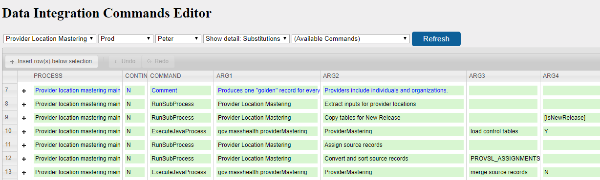
Figure 1 – A “main” process in the Data Integration Commands Editor web application
Running a DIF process executes each record in the COMMANDS table for the process in the PROCESS column, in the order shown. The order is determined by a sequence number in the database, but the web application hides the sequence number to be more user friendly. Each currently implemented type of command is described below in this document. If there is an error, execution stops unless the flag in the CONTINUE ON FAILURE column is Y.
Each command expects certain arguments. Some arguments are optional. These are documented in the DATA_INTEGRATION_COMMAND_ARGS table. The + control to the left of each row in Figure 2 shows the command in detail, including the labels that describe the arguments.
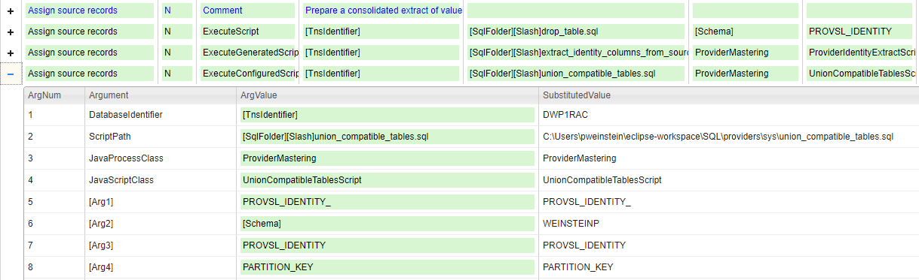
Figure 2 – Detail for each argument of a command shown in the Data Integration Commands Editor
Square brackets in DIF commands identify DIF variables. These are set either from a control table that contains location parameters, called DATA_INTEGRATION_CONTEXT, or using one of several DIF commands (SetVariable, SetVariablesWithSql, or ForEachRecordOfTable). DIF substitutes variable values before executing each command. The rightmost column in Figure 2 includes substitutions known at editing time, namely, those defined in DATA_INTEGRATION_CONTEXT.
The drop-down lists at the top of Figure 1 determine which parameters are loaded. We call each combination of the drop-down values a “context”. A context is defined by the:
- Project
- Deployment Stage (Dev, QA, Prod: which determines the database and schema)
- Job Server (currently the first name of the developer, QT for QA, or DQ for production).
Note that the values of variables may also be variables. Command instantiation continues until all variables that are recognized are substituted.

SQL in the Data Integration framework
SQL is the first choice for coding business logic. However, SQL for DIF tends to be relatively simple because much of the resource definition and data manipulation is handled by the framework. For example, when writing to database tables, DIF can automatically create a new table or drop and recreate a table if new columns have been added.

Executing SQL from DI
Typically, DIF will substitute text values into SQL script templates before executing them. These values may be script parameters, and/or schemas and tables. The fragment of SQL shown in Figure 3, for example, will create a table whose schema and name are set by the DIF command that executes the script.
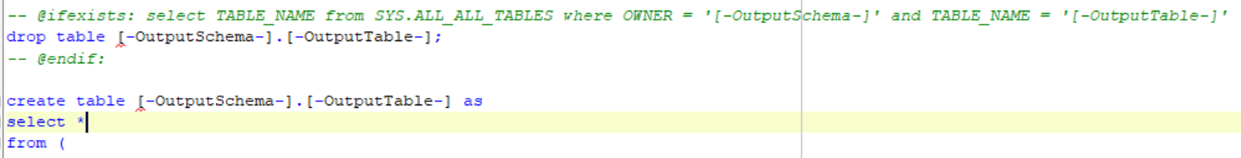
Figure 3 – A fragment of a DIF SQL template showing table creation with text substitutions
Many SQL scripts write their own output, often using create table as in Figure 3. Or, data can be returned to DIF which then writes the output, potentially to a different database. The big advantage of the former approach is that it is much faster, as data does not need to travel over the network from the database server to the job server, and back to the database server if the input and output databases are the same.
The -Verbose option is available for any Data Integration command that executes SQL. This option causes the script to be written to disk including text substitutions, in exactly the form that is executed. The destination folder is set with the VerboseFolder property in DATA_INTEGRATION_CONTEXT.
Preceding the create table command in Figure 3 is a special construct that conditionally drops the table to be re-created only if it exists. The special comments with @ifexists: and @endif: cause text between these comments to be removed if the select statement does not return any data. (A special consideration is that the framework assumes there is a script to execute, so if a script’s logic is entirely conditional, add a harmless select statement at the end just in case everything else is removed).
DIF can also generate SQL from Java, using information loaded from control tables. The mechanism is the same: text substitution into SQL templates. For these relatively dynamic scripts, however, it is common for substitutions to constitute relatively complex elements such as join clauses or sub-queries. See the SQL Generation section below for the Java details.

Support for Business Analysts
At this time (7/2021) we have taken initial steps towards realizing the potential of the Data Integration framework for supporting business analysts who work with the data. Figure 3a shows summaries of SQL scripts pulled from annotations embedded directly in the SQL. Currently, these summaries offer developers quick insight into the content of scripts. There is potential to go much further along this path of defining annotations and building functionality to support business analysts in their work. A comment inline with SQL is not necessarily up to date, but it’s adjacency to code that actually executes makes it relatively easy to maintain accuracy compared to external documentation.
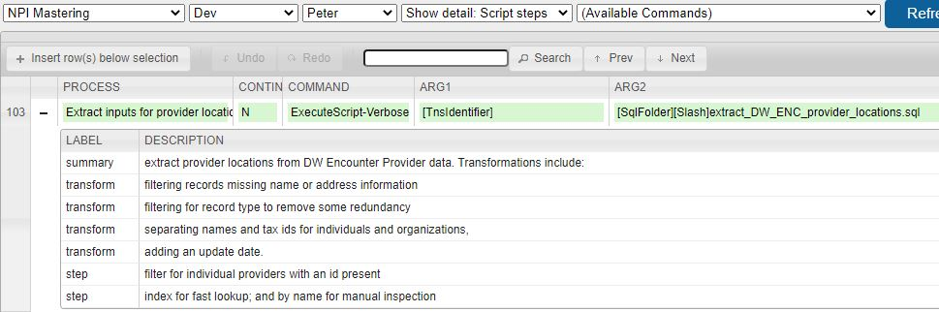
Figure 3a – Summaries from annotations in SQL scripts
Figure 3b shows the tables that are input and output from a script. In this case, the output table is parameterized in the command as ARG4. The ability to identify input and output tables comes from parsing the script, as described in the following section. When or if it becomes cost beneficial, the ability to produce data lineage will be extended to the column level of detail.
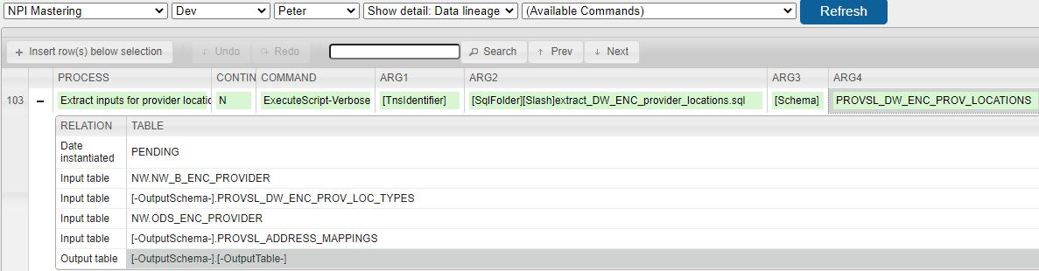
Figure 3b – Table level data lineage extracted from a SQL script

The DI SQL Parser
The Data Integration framework executes SQL using Oracle and Trino. The SQL must be valid for the executing database. The framework also executes Cypher when working with graph databases in Neo4j.
For the purpose of automating data lineage, and other analysis of data dependencies within a body of SQL, the DI framework can also interpret SQL using its own grammar-based SQL parser. This capability is functional for Oracle SQL, but is still incomplete. This section describes how this capability works to support further development. Skip this section if your interest is in using the framework for ETL.
The DI SQL parser is controlled by a grammar in a Bachus-Naur Format (BNF). It is not a complete model of Oracle SQL, that would be incredibly difficult. Instead, it is designed to interpret just the detail that we need for whatever analysis we are undertaking to develop. Currently we are using the parser to enable the data lineage dropdown in the commands editor web application, which shows input and output tables. At this time the grammar also includes a partial parsing of columns. However, more advanced features such as UNION etc. are not included. The current grammar also glosses over the content in join phrases, where clauses, and group by clauses.
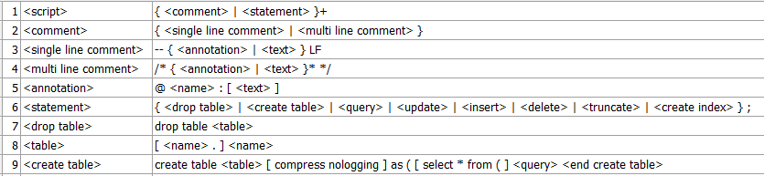
Figure 3c – Examples of the DI SQL grammar, from the table DATA_INTEGRATON_SQL_GRAMMAR
Each record of the grammar is an expansion, in which the left side is substituted by the right side as the parser moves down the tree of grammar elements. Here are the elements that are found in the grammar:
- Literals. Anything that is not explicitly in this list is a literal. Literals are matched directly to the SQL script. They are very important for the grammar because they are easy to reject, in other words, parsing a literal helps the parser align the grammar and the script.
- Terminal text elements. These are bound to text in the SQL, along with information from the grammar and contextual history from the parse tree such that the system can know the contents of the script. Terminal text elements look like expansions, but do not have their own record. So far they include:
  - <name>. These bind to single tokens that are alphanumeric, except for certain characters including _, *, [, ], and -. The token must be no longer than 50 characters.
  - <alias>. This is treated just like name but with a length limit of 10 characters.
  - <text>. This can bind to any script text. There is a column called TEXT_SENTINELS in DATA_INTEGRATION_SQL_GRAMMAR that tells the parser where to end the text binding for each expansion.
- Non-terminal expansion identifiers. For example, <comment> and <statement>. These each have their own record in the control table. If an expansion is missing, however, the log records the error but parsing continues.
- Curly brackets { and }. The closing bracket may be immediately followed without a space with either + or *. The brackets identify a group that may be repeated. The + means one or more times. The * means zero or more times.
- Square brackets [ and ]. These also create groups, however, the cardinality expected is either zero or one time. In other words, use square brackets for optional, non-repeated elements.
- Pipes |, and a special pipe that looks like |1. These occur always within curly brackets to identify disjunctive options for parsing an element. Disjunctions must be crafted such that the first option that parses successfully is the intended parse. In other words, the parser does not search for all possible parses where there are multiple options within a disjunctive group. Given the nesting of disjunctions within disjunctions, this could become very expensive computationally. The |1 symbol means that the following option will terminate parsing of a repeating group. We use it to know when a list of SELECT columns is complete. Every column is followed by a comma, and the final column is followed by FROM.
It is very important to separate elements in the grammar table with spaces, as we use spaces to split the grammar when building it from the control table. Carefully imitate the use of spaces as seen in the control table.
At this time, many scripts do not parse successfully as they were written over the past two years. According to the current grammar, certain simple conventions need to be followed in the scripts for them to parse. These include:
- Use of aliases. Tables following FROM and JOIN must be followed by aliases. Columns in SELECT statements must be preceded by an alias (e.g. M.ENTITY_ID). (Note, besides making parsing easier, this convention will also facilitate column-level data lineage).
- Every annotation must have a body of text, even if only one character. In particular, follow
-- @endif: .
with a character such as the period above.
- Create table <table> as ( <select> requires a parenthesis in front of SELECT.
And so on. You’ll need to inspect the grammar closely to see how it aligns with a particular script that you are working with. Every failure to parse can be addressed either by:
- Modifying the SQL script to fit DI conventions
- Elaborating the grammar to accommodate the script. Be sure to run a regression test to make sure that other scripts parse correctly.
- Adding new behavior to the parser. At this point, hopefully, this option will be needed rarely. The code is in the DataIntegration project, in the dataIntegration.sqlParsing package.
Finally, future work will parse SQL scripts that have been instantiated, rather than templates awaiting substitutions of parameters prior to execution.

Executables
We have been executing DIF processes in one of four ways: within the Eclipse debugger, from the command line using batch programs, from Windows Task Scheduler, or from the Data Integration Self-Service web application. We create batch programs by copying the command line from Eclipse Debug configurations. The java classpath is long and machine-specific, so each developer needs to create their own batch programs for running on their desktops.
Previously, we used a separate batch program to invoke each Data Integration process. Subsequently, we shifted to generic batch programs where the log file, Data Integration project and process are included in the arguments passed from the command line (as arguments %1, %2, and %3 respectively). Indeed, the main() function of DataIntegration can now accept any number of arguments from the command line. This is useful when running subprocesses that start with a list of values passed from the calling process. Note, these arguments are always strings, we do not have non-text variables in the framework.
Also note that DIF currently requires these system environment variables:
- TNS_FOLDER. Identifies the folder within which the tnsnames.ora file is located. This file contains instructions for connecting to Oracle databases. The sqlnet.ora file is also located in this folder. This Oracle configuration file is needed for C# programs to connect to Oracle.
- DATA_INTEGRATION_HOME. This variable points to the Execution folder and contains the DataIntegration.ini configuration file, which includes bootstrap properties that tell the web applications where to find and how to read credentials from the DATA_INTEGRATION_CONTEXT table.

Process Logs
Every DIF process generates a log, either to the console or redirected to disk. The log shows every command that executes complete with variable substitutions. For example, Figure 4 shows a value to be substituted into a script, and then execution of the script. Note there are two levels of substitution here: variables substituted into DIF commands (not shown in Figure 4 because the log is post-substitution), and parameters substituted into SQL scripts (as directed by DIF commands).
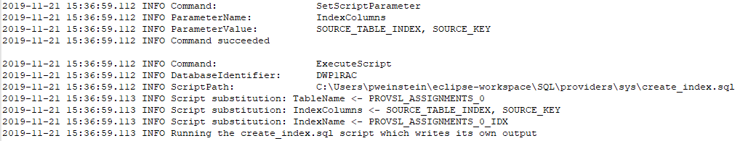
Figure 4 – A log entry showing execution of a script

Self-Service Web Application
We have developed and deployed a web application that allows authorized users to run processes on demand. Users must be registered with Virtual Gateway for authentication. Authorization is process-specific, as specified in the DI_SELF_SERVICE_PROCESSES table. The parameters for each process are defined in the DI_SELF_SERVICE_PARAMETERS table.
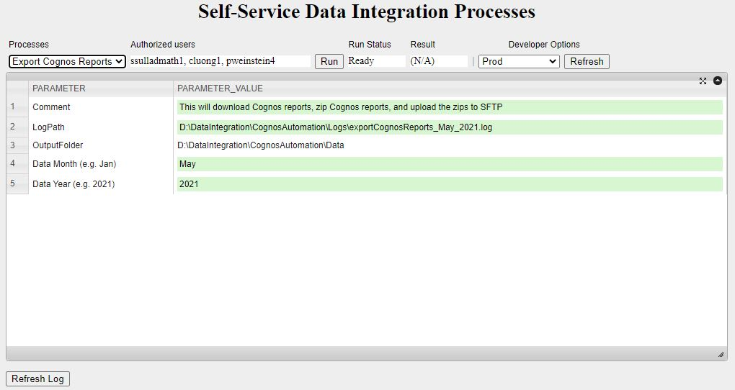
Figure 4b – The self-service web application
The self-service application posed a bit of a dilemma because there are conflicting requirements for the credentials to run the Tomcat web server, and to use the Microsoft Excel Interop library that we use to generate reports with Excel. Therefore, we developed a separate Windows application, the DiSelfServiceExecutor, to run the Data Integration processes in the background. The web application and the executor communicate using shared memory files.

Development Environments

Eclipse
We use Eclipse for developing our batch processes and web applications, running with Java 8. Version 4.16 is the last version of Eclipse compatible with Java 8. We recommend installing the Enterprise version of Eclipse 4.16, but it is also possible to install the regular version and then add some features. We use the default workspace name (eclipse-workspace).
We have a number of technical notes related to the installation of tools in Eclipse in MassForge. See MassForge > project EOHHS DW > documents > DW_Data Quality > Knowledge > How To.
Some configuration is needed to build the code that you will download from Subversion (see next section):
- Project dependencies are as illustrated in Figure 1 (Eclipse > Project Explorer > select project right click Properties > Java Build Path > Projects).
- External libraries for Oracle and sending email are available in a shared folder used by the data warehouse:
\\EHS-CLU-BOS-081\File Services\Warehouse\Data_Warehouse_Project\DataQuality\libraries.
Additional external libraries including the large number used for cloud tools can be obtained from the job servers.
- The web applications need manual configuration of the Deployment Assembly properties under Java Build Path. Figure 5 shows the current values for the ProviderMasteringReview project.
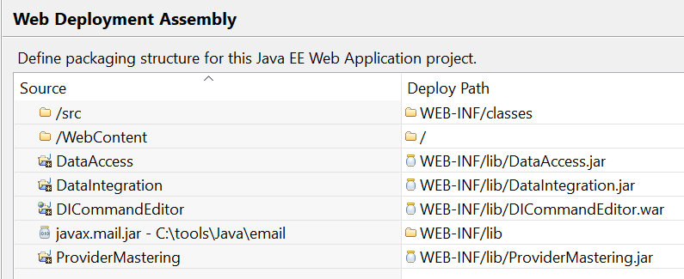
Figure 5: Additional configuration properties for web applications in Eclipse
The main() function for Provider Mastering is in gov.masshealth.providerMastering.ProviderMastering.java. The main() function for Provider Matching is in a package within the ProviderMastering project in gov.masshealth.providerMatching.ProviderMatchingProcess.java.
Both of these main() functions immediately call main() in the DataIntegration project in gov.masshealth.dataIntegration.DataIntegration.java. The reason for pointing Run/Debug configurations to the Provider Mastering and Matching main functions, rather than directly invoking DataIntegration, is so that Eclipse automatically compiles changes to these projects before execution.

Subversion
We use the Subversion (SVN) version control system from within Eclipse, where it is called Subclipse. The SVN repository is located in MassForge with the URL https://massforge.state.ma.us/svn/repository-internal/mhdwdqsvn-publishing. Figure 6 shows the top level of the repository folder structure in the SVN perspective in Eclipse. These folders are associated with local folders within our Eclipse workspace.
Use Eclipse > SVN perspective > select folder > right click Checkout to copy to your Eclipse workspace. Daily use of SVN is from the Java perspective in Eclipse, using the Update to HEAD and Commit commands on the Team menu: Eclipse > project explorer > select project right click Team.
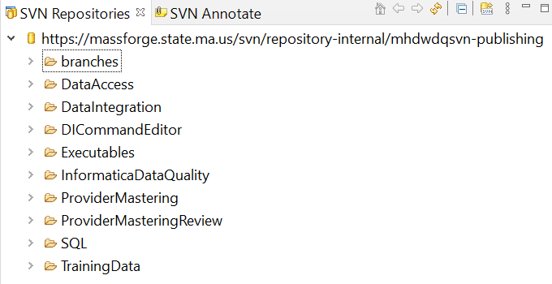
Figure 6: Top-level folder structure of SVN repository
The SQL and Executables folders contain SQL scripts and batch programs, respectively. Use Refresh (Eclipse > project explorer > select project right click Refresh) before committing to avoid SVN transfer errors. The batch programs are unfortunately loaded with machine-specific classpath information. An easy way to create batch programs for your own use is to copy from Eclipse > project explorer > select project right click Properties > Run/Debug settings > select configuration > edit > Show command line. Be sure to follow naming conventions for the batch programs, and add REMarks at the top and redirection to log output at the end.
Release versions of our systems are in SVN under the branches folder, associated with local folders in an alternative Eclipse workspace (eclipse-workspace-dq). So far, we have created only one release and by now it is out of date (7/2021). Unfortunately, branching and merging in Subversion is difficult. Instead, we have been keeping development close to production and deploying fairly often.

Web tools
For a web server for development we use Tomcat installed within Eclipse. There are a few relevant technical notes in MassForge, however in general this has worked well for us. On the application servers in AWS, Tomcat is installed and configured outside of Eclipse.
For debugging HTML and Javascript, we’ve been using Chrome.
The web applications make heavy use of the open source Javascript grid widget from ParamQuery (https://paramquery.com/) which is itself based on JQuery. A zipped copy of this tool is in \\EHS-CLU-BOS-081\File Services\Warehouse\Data_Warehouse_Project\DataQuality\backups\ParamQuery. The unzipped grid folder is located in the project in Eclipse in the WebContent folder.

Visual Studio
For exporting data to Excel and importing data from Excel we use a small C# program that we invoke from the Windows command line. This approach allows us to use the Excel Interop library, which is much easier than working with Excel from Java, and which gives a high level of control (essentially the ability to do anything that is possible within Excel, if needed). We developed this program using Visual Studio Community, which is free to the public.
The ExcelIntegration source code is stored within SVN in the Executables/other applications/ExcelIntegration folder. The files need to be manually copied between the Eclipse workspace and the Visual Studio workspace.
The sqlnet.ora file is included in ExcelIntegration folder in version control. This file includes instructions for connecting to Oracle. It must be copied to the same folder that contains tnsnames.ora (the file that describes Oracle database resources).
The ExcelIntegration.ini file must be located in the folder that contains the ExcelIntegration executable. This file includes credentials for logging in to Oracle and other databases. Note, passwords must be encrypted using the utility in the Data Access project, as is described in the section on the Data Access project, below.

Implementation
This section is for developers working on DIF using Java. Users developing ETL with SQL can safely skip this section.
DIF is implemented in Java using the Eclipse integrated development environment. JavaDoc conventions are followed although we have not yet actually generated this documentation. The Provider Mastering and Matching Developer’s Guide, available in MassForge, includes a section that describes how to configure Eclipse and other development tools.
The Data Integration Commands Editor web application is implemented using Java Server Pages and Java on the backend, and HTML with javascript in the client. The client makes heavy use of an open source javascript grid widget from ParamQuery.com. Version control is with Subversion installed as a plugin to Eclipse. The repository is https://massforge.state.ma.us/svn/repository-internal/mhdwdqsvn-publishing. The web server is Apache Tomcat. We are currently running this web application in Eclipse, although we will soon deploy on a server. Figure 7 shows elements of the system (as of 6/2020) in the Project Explorer in Eclipse.
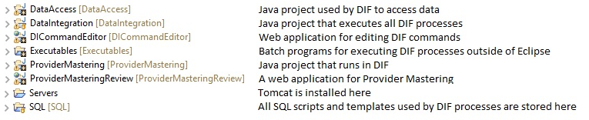
Figure 7 – Elements of the DIF system
All processes are executed 100% within DIF, except for the initial invocation. We call DataIntegration.main from the main function of Java projects (such as ProviderMastering) so that all changes to the code are recompiled before execution. DIF then calls back to Java processes defined within the Java project according to Java interfaces. This approach guarantees an orderly implementation that fits within the conventions and expectations of DIF.
The following sub-sections provide guidance to developers working with the internals of the Data Integration framework.

Data Access
The Data Integration framework accesses database and text data using the DataAccess project, with one package: gov.masshealth.dataAccess. The initial implementation was specific to Oracle as used by MassHealth data warehouse, subsequently generalized to work in the AWS with data sources including Trino, Neo4j, Cassandra via Trino, and S3 storage directly.
For developing new code, the most important classes include:
- DbAccess – Provides functions to open database connections, execute queries and other SQL, and read and write large amounts of data efficiently.
The LoadSortedTableWithCallback() function is for processing large data. The input must be sorted on an attribute; when the value of that attribute changes, the group of records is sent to the ProcessDataForAttributeValue() function that is implemented by the calling class, which implements the IDataProcessor Java interface.
The DbAccess class also handles execution of the -Force option for Data Integration commands that write to the database. If the destination table does not exist, this class generates SQL based on the data to be written to create the table. If the desired field length is not known from the query, the philosophy is to be loose about the length of text columns, so most text fields are defined either as varchar2(100), or as twice the length of the longest element in the data empirically.
The -Force option also causes the table to be dropped and recreated if the write fails because the columns aren’t quite right. This makes it very easy to add new output columns to Data Integration SQL scripts.
- DbObject – holds one record of data, including a reference to a DataTable. This is where the data type logic is.
DataTable – holds a table of data including metadata for each column (similar to the DataTable class in C#, which does not exist in Java).
Classes that are normally under the hood but good to know about include JdbcConnection and JdbcConnectionPool. Establishing JDBC connections is very slow, so we pool and reuse connections. The credentials used to create a connection determine which tables can be read and where tables can be created and written to, so the connection selected from the pool needs to be for the right database and schema. Often, all connections are for the same database and schema as established when the ETL process or web application initializes. However, the SetWriteConnection Data Integration command loads credentials from DATA_INTEGRATION_CONTEXT for writing data to a different database/schema.
Aspects of JDBC connections that are database specific are separated in separate classes. So far we have JdbcConnFuncsOracle and JdbcConnFuncsTrino. Neo4j is a graph database and does not use JDBC. We have sibling classes for working with Neo4j: Neo4jConnection instead of JdbcConnection, and Neo4jAccess instead of DbAccess.
The DataAccess project does not provide full-fledged object-relational mapping, however, there is a convenient way to specialize the generic DbObject class to have item-specific getter and setter functions to work with. The DbUtilities class with the regeneratebeans command line argument generates Java code for Provider Mastering classes defined by queries that read the key control tables for that system. In other words, if you add a column to a Provider Mastering control table, run this utility to save some time. This utility calls the DbAccess.DumpObjectCodeForQueryResults() method, which works with the template DbObjectTemplate.txt in a manner similar to how the Data Integration framework substitutes text into SQL scripts. The output then becomes the basis for Java classes such as providerMastering.MasterColumn.java that combine generated code with custom code below the line that says: --- add datatable-specific members and logic below this point ---.

Command Execution
The DataIntegration project in Eclipse implements the Data Integration framework. This code is a straightforward implementation of the functionality described in this document.
The SqlProcessRunner class executes processes, with an instance of the DIProcess class to hold state. (We would like to rename SqlProcessRunner to be DIProcessRunner because many commands do not involve SQL, however, renaming classes is sticky in Subversion so we’ve been letting this go).
The ExecuteProcess() function reads commands for a process from DATA_INTEGRATION_COMMANDS , and then executes them in sequence. The RunSubProcess command creates a new instance of SqlProcessRunner and that instance executes the subprocess. Data Integration variables created by the subprocess are released when the subprocess returns to the calling parent.
The ExecuteCommand() function processes a single command. Every Data Integration command has its own block within this function, that processes the command arguments and calls another function to do the work, which always returns success or failure.

Java Processes
The ExecuteJavaProcess Data Integration command is a hook to Java processing that can be of any nature. The Java class identified in the command arguments must implement the Java interface IJavaProcess. The step name identified in the command arguments tells the ExecuteProcess() function which process to execute. The framework calls the AddToProcess() function to add or update objects that must be kept in memory for use by subsequent Data Integration commands. In other words, the IJavaProcess class is instantiated for each ExecuteJavaProcess command. The DIProcess object held by the Data Integration framework persists for the entire process. The framework passes the DIProcess object to the IJavaProcess class to enable stateful execution.

SQL Generation
The Data Integration framework provides several commands for generating SQL scripts using Java, including ExecuteConfiguredScript. Script generation is needed when the content of the scripts depends on the content of control tables. The Data Integration framework instantiates a class that implements the ISqlScript Java interface. This class is responsible for the substitutions that convert a SQL template into executable SQL code. It knows how many substitutions there are, the label for each, and based on control tables or other information made available by the IJavaProcess class that calls it, the values for each substitution.
For the ExecuteGeneratedScripts Data Integration command and its siblings AddToTableWithGeneratedScripts and FillTableWithGeneratedScripts, the framework generates and executes a series of scripts. Typically, there is a script for each record in a control table. The knowledge of how to do this is hard-coded into the GenerateScripts() function of the IJavaProcess class, typically by conditional execution based on the class name of the ISqlScript class that knows about the substitutions to be made.

Excel Import and Export
The Data Integration Framework has commands for importing data from Excel and exporting data to Excel. The actual interaction with Excel, however, is handled by a program called ExcelIntegration implemented in C#. This program uses Microsoft’s Excel Interop library, which is much easier to use and much more powerful than available integrations of Java with Excel. To use the Excel Interop library requires an Excel license. We have found that Excel 2010 is a sufficiently modern version.
The ExcelIntegration.ini configuration file must be located in the same folder as ExcelIntegration.exe. This file includes login credentials for the database. The password must be encrypted using the encryptpassword option of the dataAccess.DbUtilities main() function. In practice, copy them from the DATA_INTEGRATION_CONTEXT table. See the Authentication section just below.
Connecting to Oracle from C# also requires an sqlnet.ora file in the TNS_ADMIN folder along with tnsnames.ora. The properties with sqlnet.ora must be coordinated with the configuration of the Oracle database. Oddly, it seems that C# requires configuration information that is not needed to connect to Oracle with Java.
The Data Integration framework calls ExcelIntegration.exe from the command line. Both importing and exporting require that the workbooks involved satisfy certain assumptions, in other words, these are workbooks specifically prepared for use with the Data Integration framework. Specifically:
- Exporting data requires an Excel (xlsx) template that includes YYYY-MM-DD in the filename. When the export workbook is saved, the current date replaces the YYYY-MM-DD.
- The template includes empty areas to receive data that have been identified with named ranges. The Data Integration framework pastes selected data into the named range starting in the upper left corner. Any rows that do not receive data are then deleted in the workbook. This means that the template should not include content to the right of the receiving area – because it might be deleted by the export. Also (this is a fine point), when outlining a receiving area, add a top-of-cells border to the row just below the receiving area. Then when rows are deleted, the workbook will still retain the bottom of the desired outline.
- When importing data, the workbook must provide the desired column names and the target data types of the table to be created. Data types are limited to: string, int, date, float. This information must be in the top two rows of the named range specified in the Data Integration command. Typically, these rows are hidden in the workbook if the workbook is used by business customers.
When the imported data comes from a pivot table or an Excel “Table”, Excel does not permit hidden rows between the visible column headers and the data. In this situation, place the hidden rows above rather than below the column headers, and indicate Y in the IsPivotTableYN argument of the ImportExcelToTable command. This tells the framework to skip the row that contains the pivot table column headings.

Data Integration Commands Editor
While it is possible in theory to develop Data Integration commands directly in the database using a client such as Toad, in practice such interfaces are too clunky to get work done without constant frustration and errors. Even though the development of the web application is still at an early stage, it has some nice features including especially the ability to show each command argument on its own line, along with the argument’s label as drawn from the DATA_INTEGRATION_COMMAND_ARGS table.
The commands editor is implemented with Java Server Pages (JSP) which generates HTML while running in Tomcat. The front end makes heavy use of the open source ParamQuery grid widget, which conveniently seeks to roughly emulate the look and feel of Excel. The backend is coded in Java using the Data Access component.
The drop downs at the top including project, database (aka deploy stage), and job identify the execution context, operationalized as the properties to be read from DATA_INTEGRATION_CONTEXT and loaded into Data Integration variables. When showing the detail of a command, the web application also shows the arguments with substitutions of variables set from the CONTEXT table.
For job servers other than DQ, the command grid is colored green which indicates it is a user input area. When the job server is DQ, however, the command grid is colored pink. This design is intended to avoid accidental editing of commands in DQ schemas. The deployment process is from Development to QA and Development to Production (we do not currently have QA to Production but this may come in the future). Thus, we never edit the pink because those changes will be overwritten by the next deploy.
Access permissions for the Data Integration Commands Editor web application are defined for each user in the DATA_INTEGRATION_ROLES and DATA_INTEGRATION_INDIV_ROLES tables. Only users listed in the INDIV_ROLES table will have write access to the commands (as of 9/4/2020 full implementation of this feature is pending integration with the AIMS WebGate agent to provider authentication of web users). Note that this authorization capability is very important because Data Integration processes have access to the Oracle databases according to credentials loaded from the DataIntegration.ini configuration file.

Authentication
Passwords in the DataIntegration.ini configuration file are encrypted with a homemade, developer friendly encryption algorithm. To encrypt passwords, use the encryptpassword command with the DbUtilities program in the DbAccess package in java. The password must be temporarily edited by the developer within the DbUtilities main() function.
If the DQ passwords change, the new passwords must be encrypted and placed into several places:
- The DATA_INTEGRATION_CONTEXT table (the CodedPassword property)
- The JdbcConnection.java class in the DbAccess package
- The ExcelIntegration.ini file in folders containing the ExcelIntegration program implemented in C#.
Sending emails from the Data Integration context requires authentication to the MassHealth email server. The email user and encrypted password are stored in the DATA_INTEGRATION_CONTEXT table with these properties: SMTP host user, and SMTP host encrypted pw. Similar properties hold credentials for copying data to and from the SFTP server.

Commands
This section lists each currently available command in alphabetical order. We implement new commands as they are needed.
Commands may have options, entered in the command column as suffixes preceded with a dash. Each option is described below the first time it appears.
The arguments for many commands are also similar or identical in function. Each of these arguments is described best the first time it appears. Arguments surrounded by square brackets are optional.

AddDataToTable
AddDataToTable -ZeroRowsOk-Verbose DbName[/Schema] ScriptPath OutputDbIdentifier OutputSchema OutputTable
The AddDataToTable command runs a SQL script, and inserts the results generated by the SQL to an existing table.
These options are available:
- -ZeroRowsOk. If the SQL generates zero rows, that is not an error. Processing continues whether or not the “Continue on Failure” flag is on for the command.
- -Verbose. Before executing the SQL script, DIF writes the instantiated script to a folder specified in the DATA_INTEGRATION_CONTEXT table. This is valuable for debugging.
The command arguments include:
- DbName[/Schema] – A label that identifies the database that the script runs against. May optionally include the schema that the script runs against, separated with a forward slash, for databases where the schema is not the same as the user (databases other than Oracle). When the database is in Oracle, the label is in the tnsnames.ora file.
- ScriptPath – the path including folders and file name identifying the SQL script template on disk
- OutputDbIdentifier – a label in the tnsnames.ora file that identifies the database that contains the table to which output is written
- OutputSchema – the schema of the output table
- OutputTable – the name of the output table

AddToTableWithGeneratedScripts
AddToTableWithGeneratedScripts -ZeroRowsOk-Verbose DbName[/Schema] ScriptPath JavaProcessClass JavaScriptSequenceClass OutDbIdentifier OutSchema OutTable
This command is the same as AddDataToTable, except that instead of executing a single SQL script, DIF executes a series of scripts, typically generated for each row of a control table (a table that configures information about the application).
- The JavaProcessClass argument holds the name of a Java class that implements the GenerateScripts() function, according to the IJavaProcess java interface.
- The JavaScriptSequenceClass argument holds the name of a Java class that knows how to instantiate the generated scripts. This Java class knows about the labels that receive substitutions in the SQL template, and the values that replace the labels, according to the ISqlScript java interface.

Comment
Comment Text1 [Text2] [Text3]
Use the Comment command to explain the commands that follow. The Data Integration Commands Editor highlights comments with blue font. Explanatory text can fit all into one cell, or can use multiple arguments to show more in the web application.

ConvertTextToAvro
ConvertTextToAvro FilePath DelimiterName [ColumnNamesStr] [DataTypesStr] ItemsQuotedYN NumExtraHeaderLines OutputFile
This command is like ImportFileToTable, except instead of writing the data to a database, it writes the data as a local file in Avro format. (We use Avro as a data format for S3 that carries schema information. Avro can be easily converted to the Parquet format which is column based and high performance for many queries. Writing Parquet directly is slow for the Data Integration framework because of the Java library that is available, so typically we write Avro and then use Trino to convert to Parquet).

CopyLargeTable
CopyLargeTable -Force FromDbIdentifier FromSchema FromTable NumericPKColumn ToDbIdentifier ToSchema ToTable
CopyLargeTable copies a database table from one location to another, replacing the existing data in the destination table. CopyLargeTable copies the data in multiple steps to avoid using more memory than is available.
The NumericPKColumn is used to partition the table to be copied. Currently, this column must be numeric. This column should be indexed for efficiency.
The -Force option takes effect if the destination table does not exist, or if the destination table does not have the same columns as the source table. It tells DIF to drop the destination table and recreate it to fit the data to be written.
When a table is recreated with –Force, some details of the table’s schema may change. Column lengths are in some circumstances calculated based on the data in the table. In general, tables created by DIF have loosely defined maximum lengths – for example, as VARCHAR2(100), even if a column really only needs a few columns.

CopyRecords
CopyRecords FromDbIdentifier FromSchema FromTable WhereClause ToDbIdentifier ToSchema ToTable ReplaceDataYN
This command selects records from a database table according the WhereClause argument (which starts with “where” and which follows SQL syntax). The records are then inserted into the destination table. If the ReplaceDataYN argument is Y, records are first deleted from the destination table using the same WhereClause.

CopyTable
CopyTable -Force FromDbIdentifier FromSchema FromTable ToDbIdentifier ToSchema ToTable
CopyTable copies a database table from one location to another, replacing the existing data in the destination table.
The -Force option takes effect if the destination table does not exist, or if the destination table does not have the same columns as the source table. It tells DIF to drop the destination table and recreate it to fit the data to be written.
When a table is recreated with –Force, some details of the table’s schema may change. Column lengths are in some circumstances calculated based on the data in the table. In general, tables created by DIF have loosely defined maximum lengths – for example, as VARCHAR2(100), even if a column really only needs a few columns.
Currently, CopyTable reads the entire table into memory on the job server, and then writes it to the destination database. We will develop a -BigData option that interleaves reading and writing when needed.

DownloadFileFromWeb
DownloadFileFromWeb Url OutputPath [FileName]
DownloadFileFromWeb downloads a file available on the web to a locally available location. If the FileName argument is provided, it uses that name instead of the name of the file on the web.

ExecuteConfiguredScript
ExecuteConfiguredScript -Verbose DbName[/Schema] ScriptPath JavaProcessClass JavaScriptClass [Arg1] [Arg2] [Arg3] [Arg4] [JavaPackage]
This command is like AddToTableWithGeneratedScripts, except that only one SQL script is configured by Java then executed. The arguments labeled Arg1 through Arg4 are optional, and may have any meaning according to the expectations of the particular JavaScriptClass. The JavaPackage argument is also optional and is not needed if an ExecuteJavaProcess task was previously executed within the DIF process. However, when this is not the case, DIF will need this argument to know the Java package that contains the JavaProcessClass and the JavaScriptClass.

ExecuteGeneratedScripts
ExecuteGeneratedScripts -Verbose DbName[/Schema] ScriptPath JavaProcessClass JavaScriptSequenceClass [Arg1] [Arg2] [Arg3] [Arg4] [JavaPackage]
This command is like AddToTableWithGeneratedScripts, except that the scripts write their own output. The arguments and java package are optional as for ExecuteConfiguredScript.

ExecuteJavaProcess
ExecuteJavaProcess JavaPackage JavaProcessClass StepName ReturnsInfoYN [Arg1] [Arg2][Arg3][Arg4][Arg5] [Arg6]
This command calls the ExecuteProcess() function defined in the JavaProcessClass within the JavaPackage. The StepName argument tells that function what to do. If ReturnsInfoYN is Y, the ExecuteProcess function returns an object that can carry any amount of information to the DIF framework, where it is available for use by subsequent java processes invoked by this or other commands. Arg1 through Arg6 are optional, and may have any meaning according to the expectations of the specific JavaProcessClass.

ExecuteScript
ExecuteScript -Verbose DbName[/Schema] ScriptPath [OutputSchema] [OutputTable] [S3DeleteBucket] [S3DeletePrefix]
ExecuteScript executes a SQL script that writes its own output. The DbName[/Schema] is a label in a tnsnames.ora file that identifies the database that the script executes against (when working with Oracle); or the catalog/schema when working with Trino or another database identifier such as neo4j and so on. The ScriptPath is a path including folder and file that holds the SQL script template in the job server’s file system.
The OutputSchema and OutputTable arguments are optional. Using these arguments is equivalent to using two SetScriptParameter commands, as described below, except that here the substitution labels are required to be exactly OutputSchema and OutputTable, as shown in Figure 8.
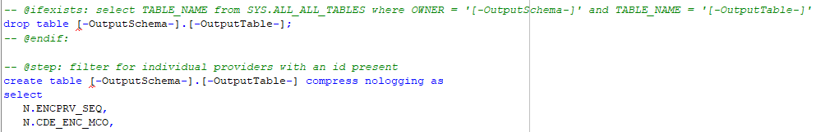
Figure 8 – A fragment of a SQL template showing conditional code
The usage pattern shown in Figure 6 is very common, and takes advantage of a special DIF feature that provides functionality equivalent to the SqlPlus exec drop_table_if_exists macro used by MassHealth Data Warehouse Operations. The -- @ifexists: annotation must be used in conjunction with the -- @endif: annotation. The select statement that follows on the same line is executed. If and only if the select statement returns a non-empty result, the SQL statements within the conditional block will execute. A SQL script may contain multiple conditional blocks. The system expects at least one SQL statement to execute: this can be a trivial “select 1 from dual” if needed.
The two optional arguments starting with S3 provide additional information needed when the output is stored in S3 in Amazon’s cloud. If the output table already exists, we need to delete the old version first. The bucket might be, for example, ehs-mhdl-np-curated. The delete prefix might be something like this: s3a://ehs-mhdl-np-curated/Providers/MasteredProvidersExtract. Note that in S3, a table is represented as a folder containing one or more files. The ExecuteScript command often creates or replaces a table. Therefore, the S3DeletePrefix is the path for the folder that contains the data files that constitute the table.

ExportDataToExcel
ExportDataToExcel ExcelTemplateFolder ExcelTemplate OutputFolder
This command writes database table into an Excel workbook that has been prepared to receive the data (the template). SetExcelExportData must be called at least once prior to calling this command. In addition, the ExcelExecutableFolder property needs to be defined in the DATA_INTEGRATION_CONTEXT table.
The ExcelTemplateFolder argument specifies the folder path where the Excel template is located. The template is a blank workbook that receives the data. Every template must have YYYY-MM-DD in its file name. This string is replaced with the date of the export when the workbook is saved as a new Excel file. The ExcelTemplate argument identifies the name of the Excel template that will be used.

ExportTableToFile
ExportTableToFile DatabaseIdentifier Schema Table WhereClause OutputPath OutputFormat
This command writes a database table to disk as a file in Avro or Parquet format. The OutputFormat argument may have values: avro, parquet.
Existing files will be overwritten. The file size must not be too big to fit in memory. For large files, use a loop in the Data Integration commands to write multiple files instead.

ExportTableToText
ExportTableToText -Overwrite-Big DatabaseIdentifier Schema Table WhereClause OutputPath DelimiterName QuotesEverywhereYN IgnoreHeadersYN SpecialFormatCode
This command writes a database table to disk as a text file, with values separated by a delimiter.
The -Overwrite option causes an existing file identified by the OutputPath argument to be replaced. Without this option, the existing file is renamed by adding a (1) after the file name stem, before the extension. If __ (1) already exists, then the existing file is renamed to __ (2), and so on.
The -Big option must be used if the table is too large to load entirely into memory.
The WhereClause applies to the select statement that loads data to write from the input table.
The DelimiterName argument must be “comma”, “pipe”, or “tab”.
If the QuotesEverywhereYN argument is Y, every data item including column names will be surrounded with quotes.
The IgnoreHeadersYN argument can be used to tell the framework not to write the column names into the first line of the output.
The SpecialFormatCode can be used to identify a set of formatting changes needed for special circumstances. The only value recognized so far is “Cognos”. This value instructs the system to match a number of idiosyncratic characteristics that occur when Cognos exports data.

ExtractDataToTable
ExtractDataToTable -Force-ZeroRowsOk-Verbose DbName[/Schema] ScriptPath OutputDbIdentifier OutputSchema OutputTable
The ExtractDataToTable command runs a SQL script, and writes the result set to a table, replacing existing data.
See above for discussion of the options and arguments.

FillTableWithGeneratedScripts
FillTableWithGeneratedScripts -Force-ZeroRowsOk-Verbose DbName[/Schema] ScriptPath JavaProcessClass JavaScriptSequenceClass OutDbIdentifier OutSchema OutTable
This command is very much like AddToTableWithGeneratedScripts, except that existing data in the OutTable is removed before writing new data. Also, the -Force option is available to create or recreate the destination table automatically if needed.

ForEachRecordOfTable
ForEachRecordOfTable -ZeroRowsOk DatabaseIdentifier Schema Table ColumnNames [WhereClause] SetVariableNames
This command creates a loop where the subsequent commands are repeated for each record loaded from the given table. The optional WhereClause must follow SQL syntax, and can also include an ORDER BY clause.
The database columns listed in ColumnNames are used to set DIF variables, whose names are listed in SetVariableNames. Use commas to separate names in these lists.
The ForEachRecordOfTable command must be followed by a NextRecordOfTable command for the same table. Multiple for loops can be nested within each other, however, they must read from different tables.
If the -ZeroRowsOk option is used, and the input table does not have any rows selected by the WhereClause, then the loop of commands is skipped.

ImportExcelToTable
ImportExcelToTable ExcelDataFolder WorkbookFile IsPivotTableYN NamedRange OutputDbIdentifier OutputSchema OutputTable
The ImportExcelToTable command copies data from a defined range in an Excel file into the database, replacing the data in the database. The database table will be created from scratch if it does not already exist, or if the columns are different. The ExcelExecutableFolder property needs to be defined in the DATA_INTEGRATION_CONTEXT table.
The ExcelDataFolder argument specifies the folder path where the Excel file is located.
The WorkbookFile argument identifies the name of the Excel file that will be imported.
The IsPivotTableYN argument must be Y if the data is a pivot table.
The NamedRange argument is the name of the defined range in the Excel file that will be imported.

ImportFileToTable
ImportTextToTable FilePath OutputDbIdentifier OutputSchema OutputTable
The ImportFileToTable command reads an Avro or Parquet file and writes the data to a database table.

ImportTextToTable
ImportTextToTable FilePath DelimiterName [ColumnNamesStr] [DataTypesStr] ItemsQuotedYN NumExtraHeaderLines OutputDbIdentifier OutputSchema OutputTable
The ImportTextToTable command copies data from a character-delimited text file into the database, replacing the data in the database table. The database table will be created from scratch if it does not already exist, or if the columns are different.
The Delimiter argument identifies the character that is the delimiter, which can be either space, comma, pipe, or tab.
The ColumnNamesStr argument has a comma-separated list of column names, e.g. PROVIDER_ID, NAME, SSN. If this argument is empty, DIF will read and use column names given in the first line of the file.
The DataTypesStr argument is a comma-separated list of data types -- or should be left empty if the datatypes are present in the second row of the input. There must be one data type for every column. Data types in the DIF command can include only: string, int, float, and date. Data types named within the file may include string, VARCHAR, TIME, int, float, NUMBER, date, or DATETIME. (Note, if other data types are present, the DelimitedFileImportExport java class can be modified to accommodate the need).
The ItemsQuotedYN argument must be Y if some or all of the input elements are surrounded by quotes.
The NumExtraHeaderLines tells DIF to skip the first x lines of the input file, in addition to lines read for column names and data types if these were read from the file.
Finally, if the input has an incorrect number of items on a line, that line will be skipped and a warning will be generated. One cause for this behavior can be delimiters embedded in the input. This is why quotes may be needed around some or all of the input items.

ListFilesInFolder
ListFilesInFolder -ZeroRowsOk FolderPath FilePattern MostRecentByDateInNameYN OutDbIdentifier OutSchema OutTable OutColumn
This command reads the list of files present in a file system folder that satisfy the given FilePattern. These filenames are then written to a table in the output database / schema / table, with the column name specified in OutColumn.
The MostRecentByDateInNameYN argument should be Y if the date is given within the file name, and we want to list only the most recent from files that have the same name except for the date. When this argument is Y, the FilePattern must include one of these literals to identify where to expect the date and the date’s format: MMDDYYYY, or YYYYMMDD.

NextRecordOfTable
NextRecordOfTable table
Closes a loop started with the ForEachRecordOfTable command. The table must be the same for the commands that start and end the loop.

PrepareToRecordJobHistory
PrepareToRecordJobHistory DbIdentifier Schema JobHistoryTable [DescriptionVariable]
Prepares to record the process’s details to the specified JobHistoryTable on the process’s exit.
On the process’s completion or failure, the main process’s details including project name, process name, process description, process datetime, completion status, and last error are recorded to the specified JobHistoryTable.
The process is responsible for setting the value of a Data Integration variable defined by the optional argument 4 (DescriptionVariable). This value will be saved into the DESCRIPTION column of the JobHistoryTable. The process may set this variable either with the SetVariableWithSql command, or within a Java process using this method on the DIProcess object:
- process. AddOrSetVariableForProcessStack().

RunShellCommand
RunShellCommand Executable Arg1 Arg2 Arg3 Arg4 Arg5 Arg6 Arg7 Arg8 Arg9
Executes a shell command. The shell command is responsible for writing its own log and for returning success / failure with a system exit code.
The Data Integration Operations project includes subprocesses that wrap functions executed from the command line. These implementations may be with shell scripts, or with executables that are programmed in another language. For example, we use C# to export and import data to and from Excel, since it is easy to use Microsoft’s Excel Interop package in C# but not in Java.

RunSubProcess
RunSubProcess DataIntegrationProject DataIntegrationProcess [Arguments] [RunOnlyIfY] [OrRunIfThis]
This command runs another DIF process, which may use any DIF variables that have already been set. The DataIntegrationProject may be any project defined with commands. The DataIntegrationProcess may be any process that has commands within the DataIntegrationProject.
The optional Arguments argument is a comma-separated list of variable values to be passed to the sub process. A SubProcess command must receive the arguments within the sub process.
The optional RunOnlyIfY argument allows for conditional execution. The subprocess is executed if this argument is either missing, Y, or equal to the OrRunIfThis argument.

S3CopyFile
S3CopyFile CopyToServerYN S3Bucket FromFilePath ToFilePath
S3CopyFile copies a file either from a local drive to Amazon’s S3 storage, or in the other direction depending on whether CopyToServerYN is Y or N. The file paths can be either Windows, Linux, or S3 style. S3 paths include a prefix and a bucket that looks like the root folder, as in this example: s3a://ehs-mhdl-np-curated/Providers/MasteredProvidersExtract.

SendEmail
SendEmail Sender Recipients Subject Body
Generates and sends an email using an SMTP server identified in the DATA_INTEGRATION_CONTEXT table. These properties must be defined for the project, job server, and deploy stage:
- SMTP host
- SMTP host user
- SMTP host encrypted pw.
The SMTP host user is a Windows username in the EHS domain. The encrypted password is the Windows password of that user, encrypted using the encryptpassword command of the DbAccess.DbUtilities program.
The Sender argument should be the email address of the authenticated emailer. The Recipients argument is a comma-separated list of email addresses. The Subject argument contains the text of the subject line, and the Body argument may contain either the text or html of the email body.
This command will also send any attachments specified by previous calls to the SetEmailAttachment command. Non-safe attachments will be skipped in any of the recipients does not have a “mass.gov” or “state.ma.us” email address.
As always, Data Integration variables are identified with square brackets, and will be substituted before executing the command. This provides a convenient mechanism for sending personalized emails if desired.

SendEmailOnFailure
SendEmailOnFailure DbIdentifier Schema RecipientsTable
Prepares to send an email if the Data Integration process fails and the exception is caught. This includes verifying authentication to the SMTP server, and loading the list of email recipients in the database table identified in the command arguments.
On failure, an email is sent to all of the recipients. The email comes from the first address in the table, as ordered by the ID column. The subject includes the name of the failed process, and the body includes the most recent error message logged.

SetEmailAttachment
SetEmailAttachment FolderPath FileName SafeOrNotYN
The SetEmailAttachment command identifies a file to be attached to an email sent by a following SendEmail command. This command can be called multiple times before SendEmail to send multiple attachments within the same email.
The FolderPath argument specifies the path of the folder where the file is located.
The FileName argument specifies the name of the file to be attached to the email.
The SafeOrNotYN argument specifies whether the attached file is safe to sent to users outside of the firewall.

SetExcelExportData
SetExcelExportData FromDbIdentifier Schema Table [ColumnsSelected] [WhereClause] [OrderClause] NamedRange
The SetExcelExportData command identifies a selection of data from a database table, to be copied to Excel by a following ExportTableToExcel command. This command can be called multiple times before ExportTableToExcel to export multiple tables to the same Excel file.
The [ColumnsSelected] argument is an optional argument to specify which columns to export. If this argument is not specified, all columns will be exported.
The [WhereClause] argument is an optional argument to specify a where clause for your export. If this argument is not specified, all records will be exported.
The [OrderClause] argument is an optional argument to specify an order clause for your export. If this argument is not specified, records will not be sorted.
The NamedRange argument is the name of the defined range in the Excel file where the data will be exported.

SetScriptParameter
SetScriptParameter ParameterName ParameterValue [EscapeSingleQuotesYN]
SetScriptParameter does a text substitution of the ParameterValue into the ParameterName label in the next script to be executed. In the script, the label is surrounded by square brackets and dashes, e.g.
[-InputTable-].
Any number of SetScriptParameter commands may precede any command that executes a script (for example, ExecuteScript, Validate, and so on).
Note, these parameters are cleared after the script is executed, so they may need to be set again before executing another script.
The optional EscapeSingleQuotesYN argument may be needed if the ParameterValue may include apostrophes, which are used in SQL syntax to identify literals.

SetVariable / SetProcessParameter
SetProcessParameter VariableName [VariableValue] [AlternativeVariableValue] [AlternativeVariableValue2] [AlternativeVariableValue3] [BackupVariableValue]
This command creates a DIF variable and sets its. The VariableName argument does not include the square brackets which identify a variable for to be substituted before execution.
Typically with SetVariable, the VariableValue argument holds the value assigned to the Variable, and the additional arguments are not used.
In comparison, the additional arguments are often used with SetProcessParameter. These optional arguments set variables using conditionals. They are only applied when VariableValue is empty or null. The example argument below sets the variable to “test” if the “DeployStage” variable is equal to Dev.
e.g. [DeployStage]=Dev=>test
The BackupVariableValue is an optional argument to specify a default value when VariableValue is empty or null and none of the AlternativeVariableValue arguments apply.
Under the hood, both of these commands are really the same. The only difference is that SetProcessParameter appears red in the DICommandEditor to highlight that it is a value that needs to be set manually prior to running the process. SetVariable appears black like other commands.

SetVariableWithProperty
SetVariableWithProperty VariableName VariableValue DeployStage JobServer DIFProject PropertyName
This command reads a property from the DATA_INTEGRATION_CONTEXT table that would not otherwise be available in the current context. Every process executes in a context defined by deploy stage, job server, and DI project. Properties are loaded automatically to be appropriate for the context.
On rare occasions, a process needs a property from another context. In other words, a property associated with a different deploy stage, job server, and/or project. In these situations, the SetVariableWithProperty command loads the desired value from DATA_INTEGRATION_CONTEXT according to the DeployStage, JobServer, and DIFProject arguments – and sets the VariableName variable with the value loaded for the PropertyName property.

SetVariables
SetVariablesWithSql -Verbose DbName[/Schema] ScriptPath VariableNames
This command sets the values of one or more DIF variables according to the results returned by a SQL script that generates exactly one record.
The VariableNames must be a comma separated list with the same number of items produced by the SQL script.

SFTPCopyFile
SFTPCopyFile CopyToServerYN FromFilePath ToFilePath
This command enables automated handling of input and output for processes that communicate with MassHealth partners using secure file transfers (SFTP). This command copies files to an SFTP server identified in the DATA_INTEGRATION_CONTEXT table using the secure copy (SCP) program that comes with PuTTY. These properties must be defined in the DATA_INTEGRATION_CONTEXT table:
- SFTP host
- SFTP host user
- SFTP host encrypted pw.
- SFTP host port
In addition, these properties must be defined for each job server:
- PuTTYFolder
- SFTP host private key
The PuTTYFolder is the folder path where PuTTY is installed on the user’s desktop. The SFTP host private key is the file path of the SFTP host private key located on the user’s desktop.
The CopyToServerYN argument specifies whether you are copying to or from the server.
FromFilePath and ToFilePath specify the file paths of the file you are copying and the location where you are copying it to.
WARNNG: To use this command, the pscp command must first be run manually from a command shell without -batch at least once for each user on each machine to respond to the prompt to save the key. Here is an example below:
D:\tools\PuTTY\pscp.exe -P 22 -l pweinstein -pw 3ioqGrliYH! -i D:\tools\ssh\id_rsa.ppk 10.195.181.132:/nhp-Provider_ID_Mapping/prod/to_ehs/???_???????_????_????????.txt D:\DataIntegration\ProviderMatching\Data\

SubProcess
SubProcess Variables
This command is the receiver for a RunSubProcess command that uses the Arguments argument. It may be located anywhere within the subprocess, but by convention is at the top immediately following a comment. It assigns each DIF variable listed in the Variables argument to the corresponding value listed by the RunSubProcess command. Both of these lists are separated by commas. Note that currently embedded commas will cause failure (we will add this ability when needed).
Variables set in a subprocess are local to that subprocess and any children processes. They are not accessible in the parent process after the subprocess completes.

Validate
Validate -Force-Verbose DbName[/Schema] ScriptPath OutputDbIdentifier OutputSchema OutTableHist
The Validation command executes an SQL script that checks data produced by the process, returning a table of messages associated with severity levels: INFO, WARNING, and ERROR. The messages are written to the job processing log, and also to the database table specified by the OutputDbIdentifier, OutputSchema, and OutTableHist arguments.
If any of the messages produced by the validation script have a severity level of ERROR, then the command returns Failure rather than Success, causing the DIF process to stop.
If you are writing a validation script, emulate an existing one such as validate_provider_matching.sql in the SQL/providers/matchMCEtoMMIS/sys folder in the SVN repository.

Future Work
Development of DIF has been on-demand: we add capabilities as they are needed. At this time (October 2021) we have already implemented functionality for table-driven ETL working with Oracle databases, and tools being used by the Analytics and Data Modernization (ADM) project including S3, Trino, and Neo4j.
In the future, we see great potential for automatic generation of data lineage, made possible by the transparency of DIF and the relative simplicity of SQL developed according to DIF conventions.
We also hope to have an opportunity to extend the transparency goal to include business analysts as well as developers. This would involve sophisticated work on the web, we will see.

Document History
When | Who | What
11/25/2019 | Peter Weinstein | Initial draft
2/18/2020 | Peter Weinstein | Added RunShellCommand
4/30/2020 | Peter Weinstein | Added SendEmail
5/20/2020 | Peter Weinstein | Added SendEmailOnFailure
5/22/2020 | Peter Weinstein | Added Authentication section
5/28/2020 | Peter Weinstein | Added SetVariableWithProperty
8/18/2020 | Calvin Luong | Added ImportExcelToTable, SetExcelExportData, ExportTableToExcel, & CopyLargeTable
9/4/2020 | Peter Weinstein | Renamed from User’s Guide to Developer’s Guide. Added description of the Java system.
10/26/2020  10/27/2020 | Calvin Luong  Peter Weinstein | Added SetProcessParameter, SFTPCopyFile, & PrepareToRecordJobHistory.  Renamed ExportTableToExcel à ExportDataToExcel  Removed SetWriteCredentials
12/23/2020 | Calvin Luong | Combined and updated SetVariable / SetProcessParameter  Added SetEmailAttachment, Updated SendEmail  Added warnings to SFTPCopyFile
1/22/2021 | Peter Weinstein | Added description of the DI SQL parser
6/1/2021 | Peter Weinstein | Additional option and argument for ExportTableToFile
7/8/2021 | Peter Weinstein | Brought the entire document up to date
10/25/2021 | Peter Weinstein | Added numerous changes for working with data sources in the cloud, including S3 storage with Avro and Parquet formats, Trino, and Neo4j.

